Business succession request for proposal
Help secure your transition from the business

With a little information, we can help you design an appropriate business succession plan that meets
your needs.
There are many succession strategies to consider. Start with a simple question to narrow down your options.

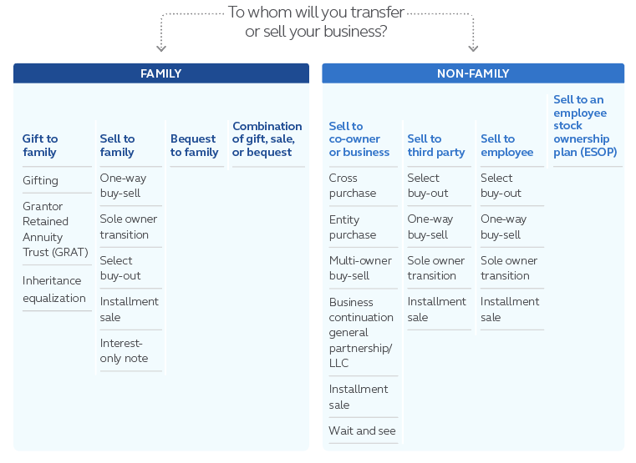
Who will you transfer the business to when you exit?
Gift to family
Bequest to family
Sell to family
Sell to co-owner or business
Sell to an employee stock ownership plan (ESOP)
Sell to employee or third party

Business profile
Business name:
Headquarters – City, State:
Issue state: |  |  |  | Nature of business (manufacturing, financial services, etc.):
Business structure: |  |  | Corporation |  |  |  |  | LLC | Partnership
 |  |  | Taxed as:  C corporation  S corporation |  |  |  |  | Taxed as:  Partnership  C corporation  S corporation | Sole proprietorship
Business tax bracket (Federal & State): |  |  |  |  |  | 21% 25% 30% 35% 40% 45%
 |  |  |  |  |  | Other:
Required information
Estimated value of the business: |  |  |  |  | Annual growth rate:
Number of years before you start the transfer or sale of business: |  |  |  |  |  |  | Number of employees:
Number of children in the business: |  |  |  | Number of children outside the business:
Owner/key employee census
(If more than 3 people, attach spreadsheet or send electronically.)
 | Name | Ownership % | Date of birth | Gender | Smoking  status | Risk  class | Tax  rate
1. |  | % |  |  |  |  | %
2. |  | % |  |  |  |  | %
3. |  | % |  |  |  |  | %
Plan design
(If more than 3 people, attach spreadsheet or send electronically.)
 | Employer contribution amount | Employee contribution amount | Face amount | Insured’s age at buy-out | Years to complete buy-out | Buy-out payment | Funding
 |  |  |  |  |  |  | Product | Interest**
1. | $ | $ | $ |  |  | $ |  | %
2. | $ | $ | $ |  |  | $ |  | %
3. | $ | $ | $ |  |  | $ |  | %
Net** Gross**
Terms of sale
- Desired future sales price:
- Down payment:
- Seller’s basis:
- Installment note details:
a. Installment note Interest-only note
b. Note terms: 5 year 10 year
c. Interest rate: |  | % |  | (We’ll assume Applicable Federal Rate (AFR) unless another rate is provided.)

Select buy-out design type
If you’re considering a Select buy-out plan, please complete this section.

Bonus design
Choose one of the options below:
Single bonus
Double bonus
Simulated salary deferral
Restrictions: Agreement to limit access to successor plan values

Select reward design
Years to  complete buy-out |  |  | Or to age  at buy-out
At fulfillment, lump sum down payment to
successor:
Tax at fulfillment: Pay tax via withdrawal from
policy cash value? Yes Other
Endorse death benefit prior to buyout? Yes No
Option A: Executive  receives level amount of |  |  |  | $
Option B: Company gets greater of
premiums* or cash value, balance to
executive: Yes Other
Economic benefit cost: Pay tax on economic benefit via out-of-pocket cash? Yes No
* Premium is determined by the amount of the lump sum down payment. Face amount is defaulted to minimum.

Proposals will NOT be provided without an indication of a valid Principal agency,
or Brokerage General Agency (BGA) office # and/or bank/wire relationship.
Required: Financial professional and proposal delivery information
Name and designations: |  |  |  | Phone:
Bank/wire relationship: |  |  |  | Email:
Principal agency/BGA office name and number: |  |  |  | Should anyone else (Financial professional or BGA)  receive this proposal?
Principal wholesaler: |  |  |  | Name:
 |  |  |  | Email address:
From receipt of completed RFP and all necessary documents, please allow 5 business days for proposals.
Questions can be sent to newrfps@exchange.principal.com
or call the Business and Advanced Solutions hotline at 833-803-8345.

